Explore Weather Trends – Project #1 Tristen Smith

1. Outline
   1. Extracted both the nearest city’s temperature data and global data using SQL queries
      1. SELECT year, city, country, avg_temp FROM city_data
      2. WHERE city='Virginia Beach'
      3. AND year BETWEEN 1750 AND 2013
      4. SELECT year, avg_temp FROM global_data
   2. Exported the data over to Excel for evaluation
   3. Calculated the 10-year moving average from 1750 to 2013 in order to smooth out the long-term data further and better visualize the results
      1. Moving averages were calculated by averaging 10 years of data while increasing the year by 1 for the next 10-year moving average
   4. Calculated the correlation coefficient to see the positive/negative correlation between both sets of data (Global vs. Virginia Beach)
      1. A key consideration to see how closely related the two datasets behaved together as the moving averages were calculated
   5. Plotted both sets of data (moving averages) on a line chart in Excel for visualization
2. Line Chart

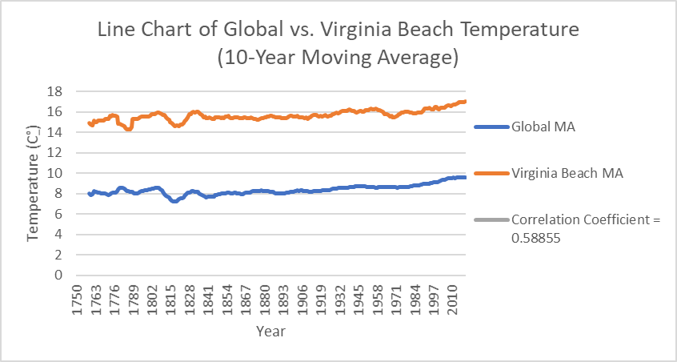

1. Observations
   1. Virginia Beach’s moving average temperature is much higher and therefore hotter than the Global moving average temperatures from 1750 to 2013. We can also see that Virginia Beach is much hotter than the rest of the world by looking at the overall average temperature with Virginia Beach being 15.65 C° whereas the global average is 8.36 C° from 1750 to 2013.
   2. Both Virginia Beach and the Global moving average temperatures increase more and more towards the 2000’s and later with the max moving average temperature for Virginia Beach being 17.33 C° in 2012 and the rest of the world being 9.67 C° in 2013. This suggests that **the world is becoming hotter.** This has been consistent since around 1840 based on the data.
   3. The correlation coefficient (0.58855) suggests that both moving average datasets are strongly correlated in the positive direction, increasing in temperature.
   4. The years between 1800 to 1820 show a downward trend in moving average temperatures for both Virginia Beach and the Global index while rapidly increasing back up again until around 1830. This signifies a change in the global temperature as a whole.